**Manuscript Preparation Guidelines for the Papers Submitted to EENET2025**

**Nattachote Rugthaicharoencheep1* Sakhon Woothipatanapan1 and Papon Ngamprasert2**

1*Department of Electrical Engineering, Faculty of Engineering, Rajamangala University of Technology Phra Nakhon

2Department of Electrical and Electronics Engineering, KOSEN - KMITL,

King Mongkut's Institute of Technology Ladkrabang

E-mail: nattachote.r@rmutp.ac.th*

**Abstract**

This document explains and demonstrates how to prepare your camera ready manuscript for the 9th Conference of Electrical Engineering Network of Rajamangala University of Technology 2023 (EENET2023). Your manuscript will appear exactly the same as it is received. Please read the guidelines and follow the instructions in this text. For the MS-Word 2003 users, the best is to use the pre-defined components found in this template.

**Keywords:** manuscript format, manuscript guidelines, text style

1. **General Information**

Contributed papers are limited to 4 pages. These limits include all figures, tables, references, and author’s biography. Please do not insert any page numbers in your paper.

Usually, each paper contains the following components: i.e. title, author’s name, author’s affiliates, abstract, sections and contents, acknowledgement (if preferred), references, and authors’ biographies (if applicable).

Please do not include any academic positions or titles to the author name. The affiliations require only the author institution. Country of the institution can be included if preferred. Different affiliations can be indicated by using superscript numbers as shown in this example. This superscript is not required for single author articles. An email is required only from the corresponding author. Please note that the corresponding author may not be the first author.

1. **Style and Format**
   1. **Paper Size and Paragraphs**

Please prepare your manuscript on A4 (21 cm x 29.7 cm) papers. The margins for the top, bottom, left, and right of the paper are 29 mm, 29 mm, 21 mm, and 21 mm, respectively.

Title, authors’ names and authors’ affiliations are in single column. The rest of the paper is in two columns with 81 mm column widths and 6 mm spacing.

All text are in single space. Different paragraphes are indicated by using an indentation of 6.3 mm. Different components, e.g. Title and authors’ names, and between sections, are spaced with an extra empty line.

* 1. **Font Style**

Font type should mimic Times New Roman. Alternatives such as Nimbus Roman, Liberation Serif can also be used. Default style and size for the content is normal and 10 pt. The different styles and sizes for different paper components are listed in Table 1.

Table 1 Font styles and sizes for different menuscript components

|  |  |  |
| --- | --- | --- |
| **Component** | **Style** | **Size** |
| Title | Bold | 12 |
| Authors’ names | Bold | 10 |
| Authors’ affiliates | Regular | 10 |
| Sections (all levels) | Bold | 11 |
| Content | Regular | 10 |
| Table contents | As appropriate | 9 |
| Captions | Regular | 8 |

* 1. **Abstract**

Abstract heading font style and sizes are bold and 11 points. Abstract contents font style and size are bold and 10 points.

* 1. **Sections**

Sections are in upper and lower case bold letter. They should appear with sequential numbers, left-hand justified. Subsections such as 2.1 and 2.1.1 can be used but subsections deeper than 3 levels, e.g. 2.1.1.1 are not recommended.

* 1. **References**

The heading of the References section must not be numbered. The references will be numbered in order of appearance. Do not use “Ref. [3]” or “Reference [3]” except at the beginning of the sentence, e.g. “Reference [3] shows …”. Multiple references are numbered together (e.g. [1 – 3]). Please avoid listing references that do not appear in the text. The reference format is the standard IEEE one. The guideline can be found at <http://www.ieee.org/documents/ieeecitationref.pdf>.

The references given in this template include a book [1], a handbook [2], a journal article [3], and a conference article [4]. References in Thai can also be listed using English with “(in Thai)” at the end of the list as shown in [5].

* 1. **Equations**

Equations should be numbered and should be placed on separated lines. The equation number should be placed in parenthesis and flushed with the right-hand margin. MS-Word 2003 users can make this possible by using 3 columns table with invisible borders.

 (1)

* 1. **Figures and Tables**

All figures and tables should be centered on the column. Please make sure that the resolution of the figure is high enough for print quality (300 dpi).

Fig. 1 illustrates an example of a figure. Please do not show figure that you have not mention in the main text.

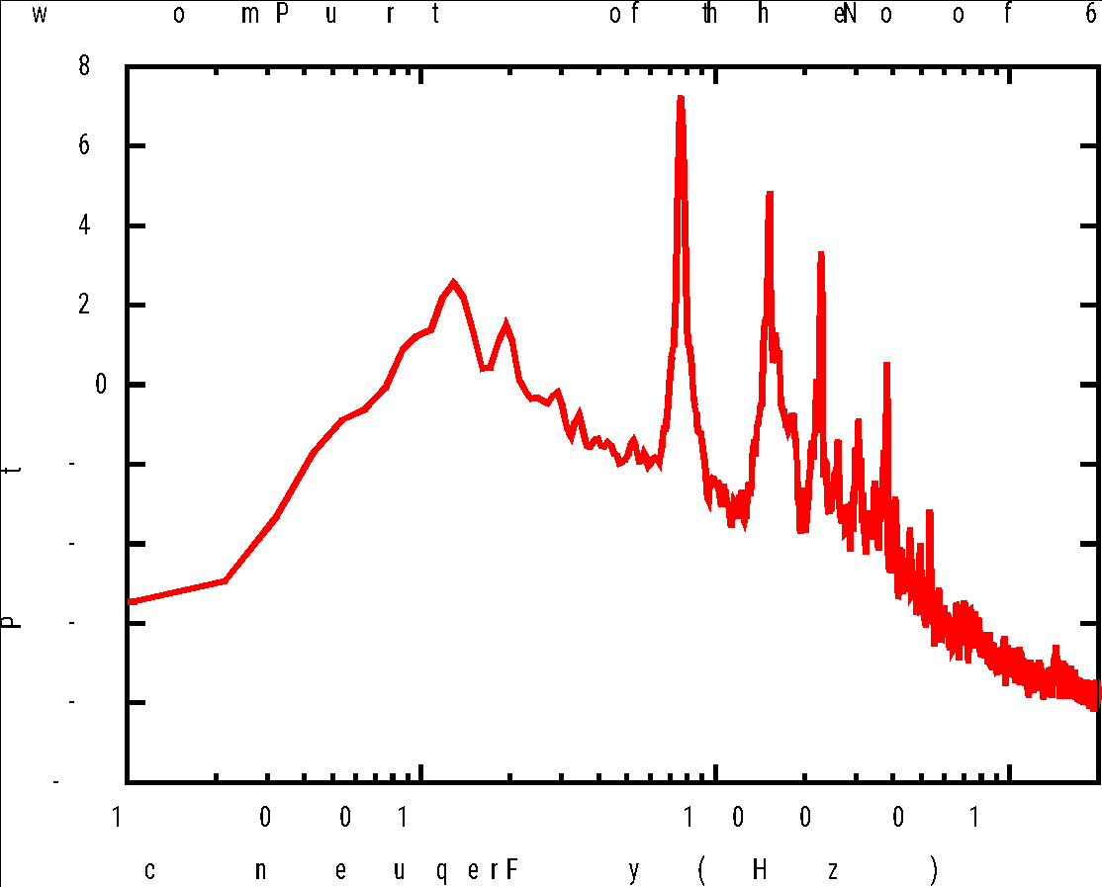

Fig. 1 An example of a figure

The caption format is given in Table 1. All captions are centered. Figure caption must be used in the form “Fig. 1”. The caption is placed below the figure.

Table caption must be used in the form “Table 1”. The caption is placed above the figure. Table 1 shows and example of a table.

1. **Discussion**

This guideline purposes are to help authors to prepare their manuscript for a good readability. The unmentioned document parameters are left for author choice of preference. However, the best is to prepare your document based on this MS-Word 2003 template. This template is available at

<https://eenet2023.fit.rmuti.ac.th/>.

1. **Conclusion**

The authors are fully responsible for their manuscripts. Please check your manuscript carefully before submission.

**References**

1. J. W. Nilsson and S. A. Riedel, “Sinusoidal steady-state analysis,” in *Electric Circuits*, 7th ed.: Prentice Hall, 2005, ch. 9, pp. 380 – 447.
2. *MATLABProgramming Fundamentals*, MathWorks, Natick, MA, 2013.
3. J. K. Author, “Title of paper,” in Unabbreviated *Name of Conf.*, City of Conf., Abbrev. State (if given), year, pp. xxx-xxx.
4. Y. Yorozu, M. Hirano, K. Oka, and Y. Tagawa, “Electron spectroscopy studies on magneto-optical media and plastic substrate interface,” *IEEE Transl. J. Magn.* Japan, vol.2, pp. 740-741, August 1987.
5. K. Nuaekaew et al., “Study and analysis feasibility use of a pneumatic muscle actuator for a CPM,” in *the 29th Electrical Engineering Conference*, Chonburi, Thailand, 2006, pp. 1097 – 1100, (in Thai).
6. Chankhamrian, W., Bhumkittipich, K., & Phankong, N.(2014). Transformerless Distribution Voltage Restorer using Diode-Clamped Three-level Converter. *In the 2014 International Electrical Engineering Congress (iEECON2014)*, Chonburi, Thailand.

|  |  |
| --- | --- |
| Scanned Picture  2 cm x 2 cm | **About the authors** the author should include a brief biography, research interest and scanned photo in the camera-ready manuscript only. |